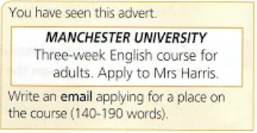

**Applying for a course**

Dear Sir/Madam,

I am writing you in order to apply for the intensive Spanish course which starts this February at Spanish Institute.

I am twenty years old and I am studying for my Bachelor degree in Software Engineering at KPI. I had experience of studying Spanish when I was in school, however it has been a long time since I actually practiced it. Aside of Spanish I have also studied English and German on my own.

This course would be extremely rewarding for me to improve my Spanish as I want to enroll into Spanish university for my Masters degree. I hope to pass exam for level B2 in the future. In general, it would be a wonderful opportunity to master another language especially such beautiful one as Spanish.

I am fully aware of the fact that you have limited available places for this course, but I hope that you will consider my application. Please, find enclosed my CV and contact details as well as a reference from my Spanish teacher. I look forward to your response.

Yours faithfully,

Roman Bessmertnyi